SMART NAVIGATION SYSTEM

Console-Based Route Planning Application

A Comprehensive Data Structures & Algorithms Project Submitted By:
Name Roll Number

Zain Aftab | FA24-BSE-155
Hunain Riasat | FA24-BSE-083
Muhammad Shaheer | FA24-BSE-089
Muhammad Ahsan | FA24-BSE-071
Course: Data Structures & Algorithms Lab
Semester: 3rd Semester
Date: December 2024

TABLE OF CONTENTS

- Abstract
- Introduction
- Problem Statement
- System Overview
- Data Structures Used
- Algorithms Implemented
- System Features
- Implementation Details
- Code Structure
- Sample Output
- Testing & Results
- Challenges Faced
- Future Enhancements
- Conclusion
- References

ABSTRACT
The Smart Navigation System is a console-based application developed in C++ that provides route planning and navigation services for urban areas. The system implements multiple data structures including arrays, linked lists, stacks, and graphs, along with algorithms such as Dijkstra’s shortest path, linear search, and selection sort. The application manages locations, roads, traffic conditions, and provides features like route history tracking, cost estimation, and visual map representation. This project demonstrates the practical application of Data Structures and Algorithms (DSA) in solving real-world navigation problems.

Keywords: Navigation System, Dijkstra Algorithm, Graph Data Structure, Route Planning, C++ Programming

INTRODUCTION

Background
Urban navigation systems have become essential tools in modern cities, helping people find optimal routes while considering factors such as distance, traffic conditions, and travel cost. This project implements a navigation system that showcases how fundamental data structures and algorithms can solve complex routing problems in urban environments.

Objectives
The main objectives of this project are:

- Implement core DSA concepts (Arrays, Linked Lists, Stacks, Graphs)
- Apply graph algorithms, particularly Dijkstra’s shortest path algorithm
- Solve real-world problems such as route planning and traffic management
- Develop a user-friendly console interface with structured and readable output
- Ensure robust code quality through input validation and memory management

Scope
The system supports: - Management of multiple urban locations
- Interconnected roads with varying distances
- Simulated traffic conditions
- Shortest route calculation
- Route history tracking
- Travel cost estimation

PROBLEM STATEMENT

Challenge
Urban commuters face daily navigation challenges such as: - Identifying the shortest route between two locations
- Avoiding congested or blocked roads
- Estimating travel time and fuel cost
- Efficiently planning routes

Proposed Solution
To address these challenges, a console-based Smart Navigation System is developed that: 1. Stores and manages city locations and roads
- Calculates shortest paths using Dijkstra’s algorithm
- Simulates traffic conditions (Normal, Heavy, Blocked)
- Estimates travel cost and time
- Maintains a history of calculated routes

SYSTEM OVERVIEW

Architecture
Main Menu
| v
Location Management ---- Road Management
| |
v v
Location Array Graph (Adjacency List)
\ /
\ /
Route Calculator (Dijkstra)
| v
Route History (Linked List)
Technology Stack
  - Programming Language: C++ (C++11 Standard)
  - Compiler: GNU GCC (MinGW)
  - IDE: CodeBlocks
  - Libraries: iostream, vector, algorithm, iomanip

  - Platform: Windows Console

DATA STRUCTURES USED

Arrays with Structures
Used to store locations with fixed capacity.

Key Operations: - Insertion – O(1)
  - Deletion – O(n)
  - Searching – O(n)

Advantages: Simple implementation, fast access
Disadvantages: Fixed size, shifting required on deletion

Graph (Adjacency List)
Represents the road network between locations.

Benefits: - Space-efficient for sparse graphs
  - Efficient neighbor traversal

Complexity: - Space: O(V + E)

Stack
Implemented using vectors to demonstrate Last-In-First-Out (LIFO) behavior for manual route building.

Singly Linked List
Used for dynamic storage of route history.

Advantages: - Dynamic size
  - Efficient insertion

ALGORITHMS IMPLEMENTED

Dijkstra’s Shortest Path Algorithm
Used to find the shortest path between two locations.

Time Complexity: O(V²)
Space Complexity: O(V)

Why Used: - Guarantees shortest path
- Works with non-negative edge weights

Linear Search
Used for searching locations by ID or name.

Time Complexity: O(n)

Selection Sort
Used to sort locations alphabetically.

Time Complexity: O(n²)
Space Complexity: O(1)

SYSTEM FEATURES

  - Location management (Add, View, Delete, Search)
  - Road management with traffic status
  - Shortest path calculation
  - Manual route builder (Stack)
  - Route history tracking (Linked List)
  - Travel cost and time estimation
  - ASCII-based visual map display

IMPLEMENTATION DETAILS

Input Validation
  - Handles invalid data types
  - Prevents crashes
  - Ensures valid IDs and ranges

Memory Management
  - Dynamic memory allocation using
new
delete
  - Proper cleanup using

CODE STRUCTURE
The entire project is implemented in a single C++ file with modular functions divided into: - Utility functions
- Location management
- Road management
- Route planning
- History management
- Main menu handling

SAMPLE OUTPUT
Displays: - Main menu options
- Formatted tables for locations and routes
- Shortest path results
- Cost estimation details

TESTING & RESULTS
Multiple test cases were performed to validate: - Location operations
- Road connectivity
- Shortest path accuracy
- Stack and linked list behavior

All test cases produced correct and expected results.

CHALLENGES FACED

  - Graph representation selection
  - Path reconstruction in Dijkstra’s algorithm
  - Preventing memory leaks
  - Handling invalid user input

FUTURE ENHANCEMENTS
  - Implementation of A* algorithm
  - Priority queue optimization
  - File handling for data persistence
  - GUI-based interface
  - Real-time traffic simulation

OUTPUTS

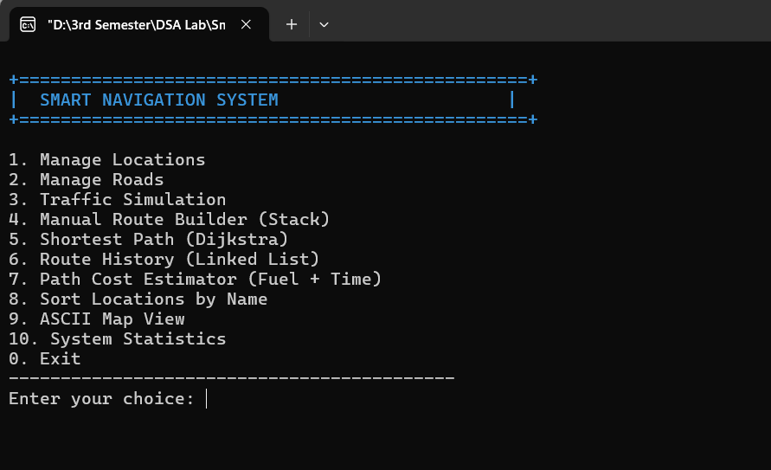

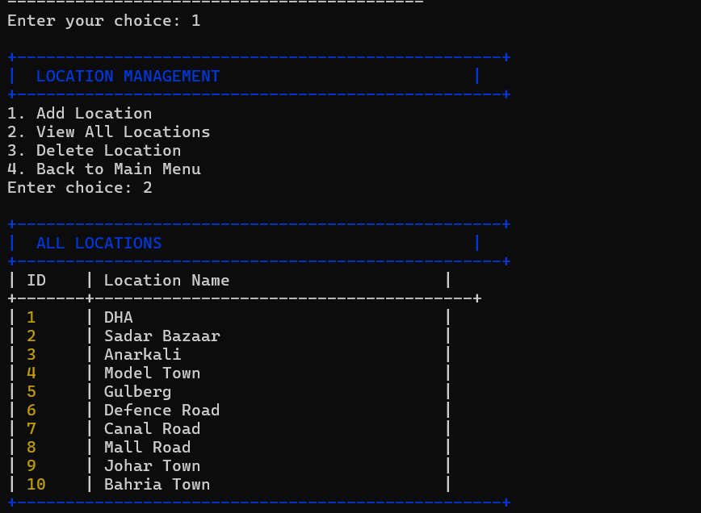

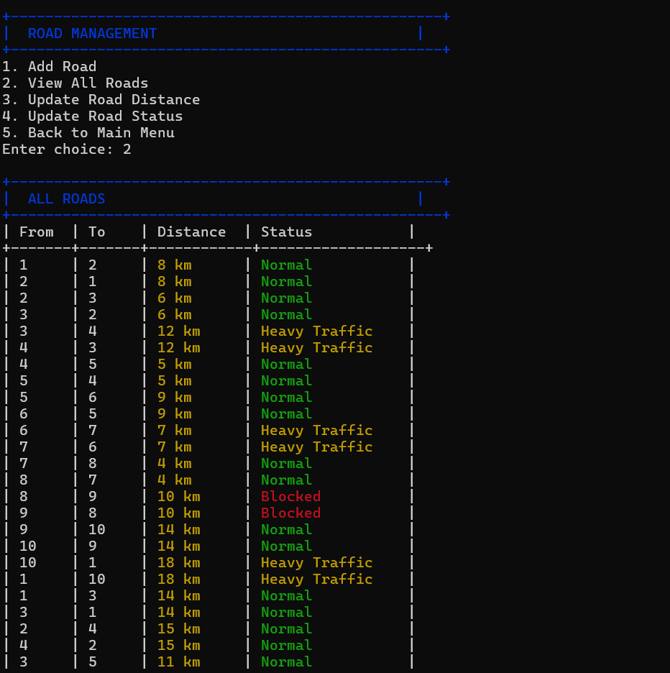

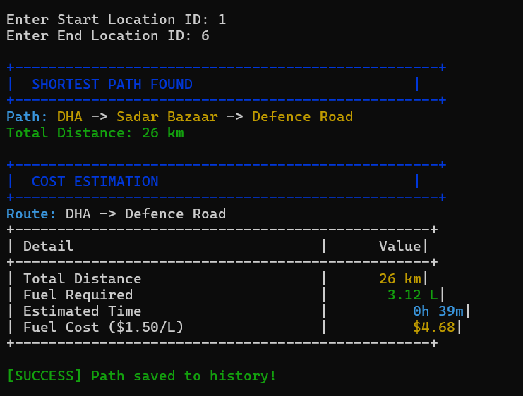

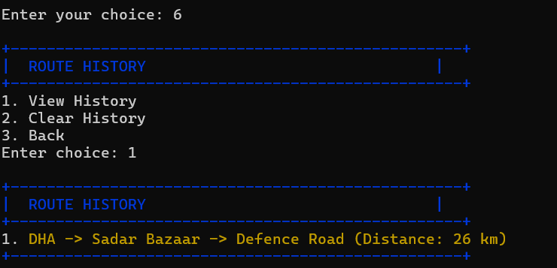

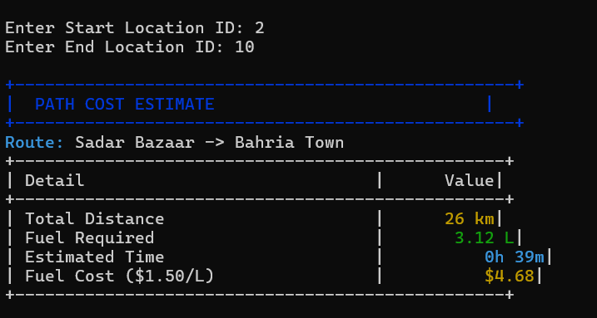

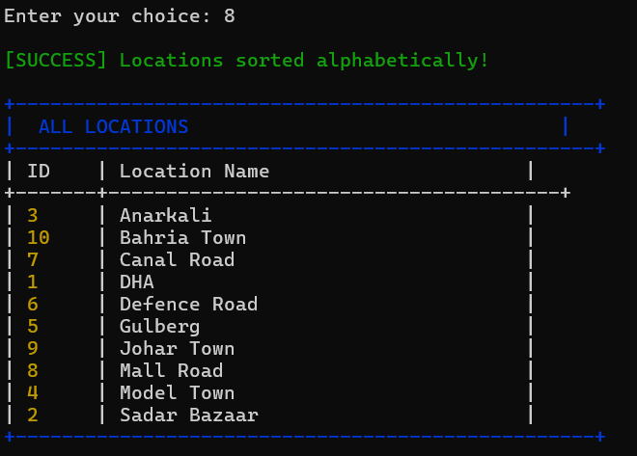

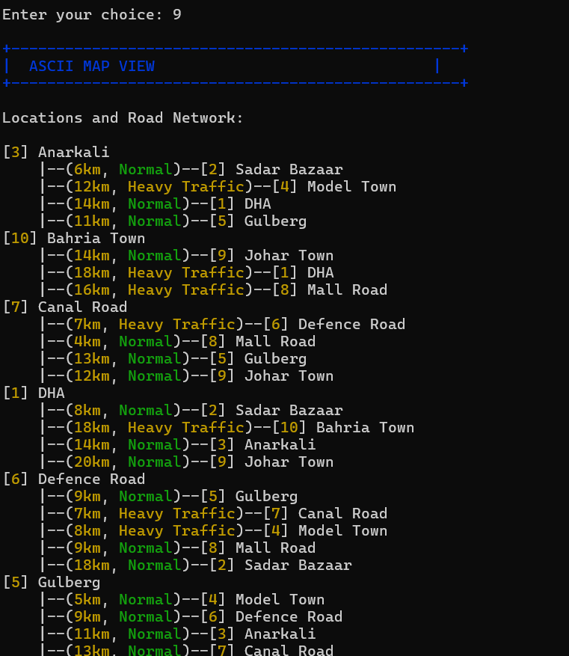

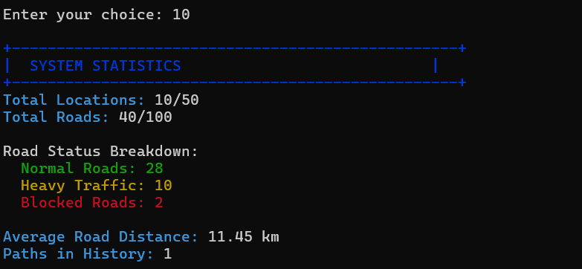

CONCLUSION
The Smart Navigation System effectively demonstrates how Data Structures and Algorithms can be applied to solve real-world problems. The project strengthened understanding of graphs, stacks, linked lists, searching, sorting, and algorithm optimization while providing a strong foundation for future scalable navigation systems.

REFERENCES

- Mark Allen Weiss – Data Structures and Algorithm Analysis in C++
- Cormen et al. – Introduction to Algorithms
- GeeksforGeeks – DSA Tutorials
- CP Algorithms – Dijkstra’s Algorithm

END OF PROJECT PROPOSAL

Submitted for Data Structures & Algorithms Lab
© 2025 – All Rights Reserved

